**Tallinna Tööstushariduskeskus  
Logistika IT süsteemide spetsialist**

**Projekti „Labürint“**Praktiline töö

**Juhendaja**: Marina Oleinik **Koostaja**: Julia Postnikova **Rühm**: LOGITpv23

**Tallinn 2024**

Sisukord

Sissejuhatus 3

Teoreetiline osa 4

# Sissejuhatus

Selle projekti eesmärk on luua hea ja huvitav tähelepanelikkuse mäng lastele ja täiskasvanutele. Tehakse labürint mõningate modifikatsioonidega. Mängus on kolm taset ja pärast mängu läbimist küsitakse, kas soovite uuesti mängida või väljuda. On ka lõbus muusika, et sul ei oleks igav.

# Teoreetiline osa

Programm kasutab Pythoni keelt.

See kasutab ka Pygame'i mooduleid.

Python ilmus 20. veebruaril 1991. Autor Guido van Rossum.

Pygame ilmus 28. oktoobril 2000. Autor Pete Shinners.

Minu kasutatud moodulid on järgmised:

import pygame

import random

Programmi põhikonstruktsioonid:

Loops

while True:

screen.fill(lBlue)

end_text = font.render("Sa oled kõik tasemed läbinud!", True, black)

continue_text = font.render("Kas soovite jätkata (J) või väljuda (V)?", True, black)

screen.blit(end_text, (scr_w // 2 - end_text.get_width() // 2, scr_h // 2 - 40))

screen.blit(continue_text, (scr_w // 2 - continue_text.get_width() // 2, scr_h // 2 + 10))

pygame.display.update()

for event in pygame.event.get():

if event.type == pygame.QUIT:

pygame.quit()

quit()

if event.type == pygame.KEYDOWN:

if event.key == pygame.K_j:

restart_game()

return

elif event.key == pygame.K_v:

pygame.quit()

quit()

def, mis võimaldab luua uusi funktsioone

def create_cell(x, y):

return {"x": x, "y": y, "walls": [True, True, True, True], "visited": False}

Klahvide juhtimine

if keys[pygame.K_LEFT] and plr_x > plr_r:

new_x -= plr_speed

if keys[pygame.K_RIGHT] and plr_x < scr_w - plr_r:

new_x += plr_speed

if keys[pygame.K_UP] and plr_y > plr_r:

new_y -= plr_speed

if keys[pygame.K_DOWN] and plr_y < scr_h - plr_r:

new_y += plr_speed

Audio

pygame.mixer.music.load('audio.mp3')

pygame.mixer.music.play()

# Praktiline osa

Kui ma hakkasin seda projekti tegema, joonistasin kõigepealt koodi välimuse ja selle, mida ma

tahtsin koodis näha. Mõtlesin, et mängul oleks mitu taset ja et inimene valiks, kas ta tahab uuesti mängida või lõpetada. Siis hakkasin koodi kirjutama, parandasin palju ja lisasin palju uusi asju.

Siin on kood ise:

import pygame

import random

pygame.init()

scr_w, scr_h = 640, 480

cell_size = 40

cols, rows = scr_w // cell_size, scr_h // cell_size

screen = pygame.display.set_mode((scr_w, scr_h))

pygame.display.set_caption('Labürint')

pygame.mixer.music.load('audio.mp3')

pygame.mixer.music.play()

lBlue = (153, 255, 255)

lPurple = (204, 153, 255)

blue = (51, 153, 255)

red = (255, 0, 0)

black = (0, 0, 0)

purple = (76, 0, 153)

plr_r = 10

plr_speed = 5

start_x, start_y = 0, rows - 1

end_x, end_y = cols - 1, 0

plr_x = start_x * cell_size + plr_r

plr_y = start_y * cell_size + plr_r

clock = pygame.time.Clock()

level = 0

max_levels = 3

font = pygame.font.SysFont(None, 36)

def create_cell(x, y):

return {"x": x, "y": y, "walls": [True, True, True, True], "visited": False}

def draw_cell(cell, cell_size, screen, blue):

x = cell["x"] * cell_size

y = cell["y"] * cell_size

if cell["walls"][0]:

pygame.draw.line(screen, blue, (x, y), (x + cell_size, y), 2)

if cell["walls"][1]:

pygame.draw.line(screen, blue, (x + cell_size, y), (x + cell_size, y + cell_size), 2)

if cell["walls"][2]:

pygame.draw.line(screen, blue, (x + cell_size, y + cell_size), (x, y + cell_size), 2)

if cell["walls"][3]:

pygame.draw.line(screen, blue, (x, y + cell_size), (x, y), 2)

def create_grid():

return [[create_cell(x, y) for x in range(cols)] for y in range(rows)]

def generate_maze():

grid = create_grid()

stack = []

current_cell = grid[start_y][start_x]

current_cell["visited"] = True

while True:

neighbors = []

x, y = current_cell["x"], current_cell["y"]

if y > 0 and not grid[y - 1][x]["visited"]:

neighbors.append(grid[y - 1][x])

if y < rows - 1 and not grid[y + 1][x]["visited"]:

neighbors.append(grid[y + 1][x])

if x > 0 and not grid[y][x - 1]["visited"]:

neighbors.append(grid[y][x - 1])

if x < cols - 1 and not grid[y][x + 1]["visited"]:

neighbors.append(grid[y][x + 1])

if neighbors:

next_cell = random.choice(neighbors)

stack.append(current_cell)

if next_cell["x"] == current_cell["x"] + 1:

current_cell["walls"][1] = False

next_cell["walls"][3] = False

elif next_cell["x"] == current_cell["x"] - 1:

current_cell["walls"][3] = False

next_cell["walls"][1] = False

elif next_cell["y"] == current_cell["y"] + 1:

current_cell["walls"][2] = False

next_cell["walls"][0] = False

elif next_cell["y"] == current_cell["y"] - 1:

current_cell["walls"][0] = False

next_cell["walls"][2] = False

current_cell = next_cell

current_cell["visited"] = True

elif stack:

current_cell = stack.pop()

else:

break

return grid

def reset_player():

global plr_x, plr_y

plr_x = start_x * cell_size + plr_r

plr_y = start_y * cell_size + plr_r

def next_level():

global level, grid

level += 1

if level < max_levels:

grid = generate_maze()

reset_player()

else:

end_game()

def end_game():

pygame.mixer.music.stop()

while True:

screen.fill(lBlue)

end_text = font.render("Sa oled kõik tasemed läbinud!", True, black)

continue_text = font.render("Kas soovite jätkata (J) või väljuda (V)?", True, black)

screen.blit(end_text, (scr_w // 2 - end_text.get_width() // 2, scr_h // 2 - 40))

screen.blit(continue_text, (scr_w // 2 - continue_text.get_width() // 2, scr_h // 2 + 10))

pygame.display.update()

for event in pygame.event.get():

if event.type == pygame.QUIT:

pygame.quit()

quit()

if event.type == pygame.KEYDOWN:

if event.key == pygame.K_j:

restart_game()

return

elif event.key == pygame.K_v:

pygame.quit()

quit()

def restart_game():

global level, grid

level = 0

grid = generate_maze()

reset_player()

pygame.mixer.music.play()

grid = generate_maze()

while True:

for event in pygame.event.get():

if event.type == pygame.QUIT:

pygame.quit()

quit()

keys = pygame.key.get_pressed()

new_x, new_y = plr_x, plr_y

if keys[pygame.K_LEFT] and plr_x > plr_r:

new_x -= plr_speed

if keys[pygame.K_RIGHT] and plr_x < scr_w - plr_r:

new_x += plr_speed

if keys[pygame.K_UP] and plr_y > plr_r:

new_y -= plr_speed

if keys[pygame.K_DOWN] and plr_y < scr_h - plr_r:

new_y += plr_speed

plr_rect = pygame.Rect(new_x - plr_r, new_y - plr_r, plr_r * 2, plr_r * 2)

collision = False

for row in grid:

for cell in row:

cx, cy = cell["x"] * cell_size, cell["y"] * cell_size

if cell["walls"][0] and plr_rect.colliderect(pygame.Rect(cx, cy, cell_size, 2)):

collision = True

if cell["walls"][1] and plr_rect.colliderect(pygame.Rect(cx + cell_size - 2, cy, 2, cell_size)):

collision = True

if cell["walls"][2] and plr_rect.colliderect(pygame.Rect(cx, cy + cell_size - 2, cell_size, 2)):

collision = True

if cell["walls"][3] and plr_rect.colliderect(pygame.Rect(cx, cy, 2, cell_size)):

collision = True

if not collision:

plr_x, plr_y = new_x, new_y

if (plr_x // cell_size == end_x and plr_y // cell_size == end_y):

next_level()

screen.fill(lBlue)

for row in grid:

for cell in row:

draw_cell(cell, cell_size, screen, blue)

pygame.draw.rect(screen, black, (start_x * cell_size, start_y * cell_size, cell_size, cell_size))

pygame.draw.rect(screen, red, (end_x * cell_size, end_y * cell_size, cell_size, cell_size))

pygame.draw.circle(screen, lPurple, (plr_x, plr_y), plr_r)

level_text = font.render(f"Level: {level + 1}", True, purple)

screen.blit(level_text, (10, 10))

pygame.display.update()

clock.tick(60)

# Mängu välimus

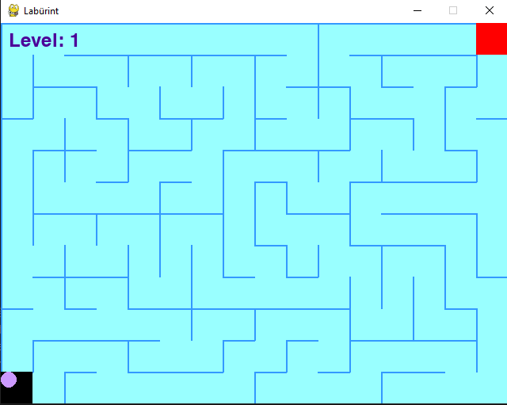

Pilt 1 "Kujundus loomine"

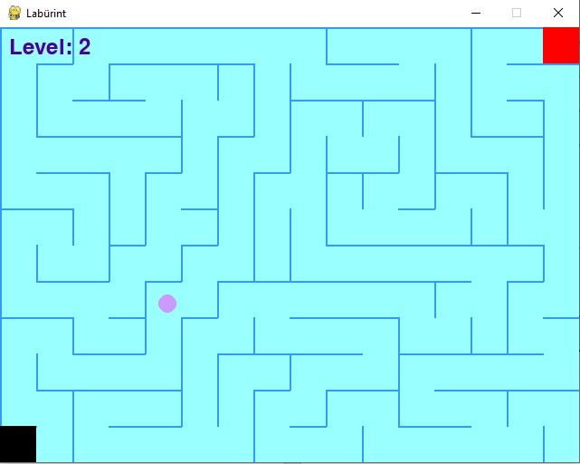

Pilt 2 "Kujundus loomine"

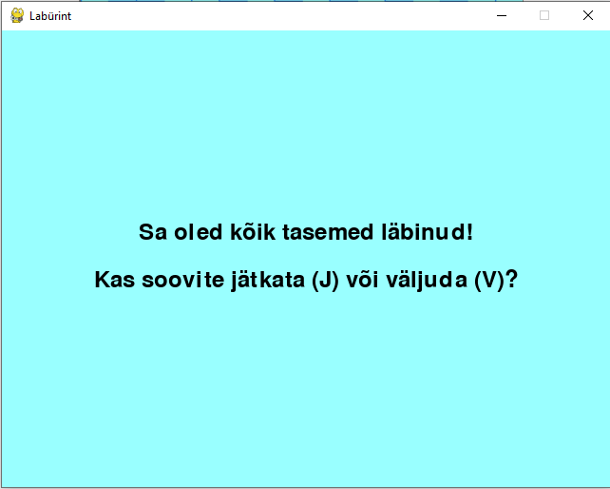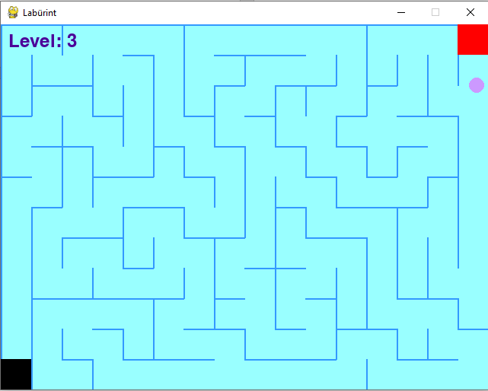

Pilt 3 "Kujundus loomine"

Pilt 4 "Kujundus loomine"

Pildid näitavad, kuidas mäng on kujutatud. Must ruut on see, kust me alustame, punane ruut on see, kuhu me peame minema. Samuti on kirjas, millisel tasemel me oleme. Kui oleme mängu läbinud, siis on küsimus, mida me tahame edasi teha.

# Kokkuvõte

Mäng töötab hästi ja ma olen sellega rahul. Tulevikus lisaksin veel funktsioone, aga ma ei ole veel ühtegi välja mõelnud.

# Allikad

# Bibliograafia

Rossum, G. v. (20. veebruar 1991. a.). Allikas: https://ru.wikipedia.org/wiki/Python

Shinners, P. (28. oktoober 2000. a.). Allikas: https://ru.wikipedia.org/wiki/Pygame